Nonviolent Community Safety and Peacekeeping:

an eight-week pt’chang course

Safe, effective ways of intervening in aggressive situations and interrupting violence

Defining safety, power and control

Assertive communication skills

De-escalating and responding to conflict creatively

Basic mediation skills

Skills and strategies for creating real safety in our lives and communities

Thursday evenings: 13 September to 1 November
6.30pm – 9.30pm (8 sessions)

Yarra Community Youth Centre, Fitzroy

An eight-session course for people wanting to learn skills and explore community-building and empowering approaches to creating safety. This is an introductory course for people wanting to volunteer for Pt’chang projects but is open to anyone wishing to explore nonviolent community safety skills and approaches.

Highly practical and skill-based, this unique training course brings together models and experience from around the world, and covers topics ranging from nonviolent interventions to looking after ourselves. There are real and effective alternatives to violence, security cameras and increased private security.

Pt’chang is an all-volunteer community group which has been organising community safety and peacekeeping projects for over five years. All sessions delivered by experienced Pt’chang Trainers.

Booking for the entire course is essential.- Unwaged: $80 Part -waged: $110 Fully waged: $150

Spaces are limited. Part payment must be received by 31 August. All Pt’chang training is highly subsidised – cost is negotiable. To book phone/fax: 03 9415 6642 or email: ptchang@office.minihub.org
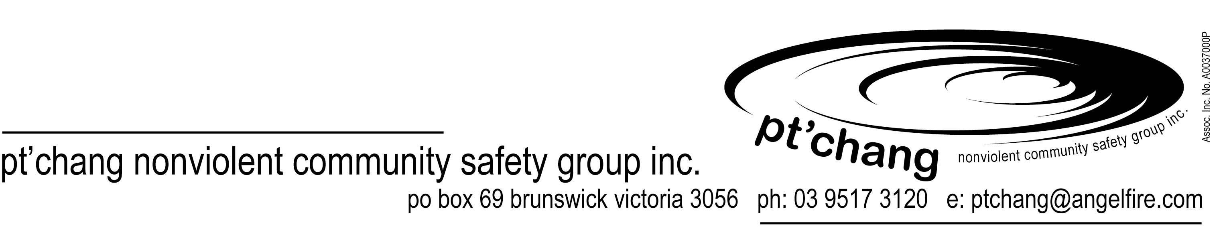
Nonviolent Community Safety and Peacekeeping:
An eight-week pt’chang course

Thursday evenings: 13 September to 1 November
6.30pm – 9.30pm (8 sessions)
Yarra Community Youth Centre, Fitzroy

Booking for the entire course is essential.
Unwaged: $80 Part-Waged$110 Fully Waged: $150

Spaces are limited. All Pt’chang training is highly subsidised – cost is negotiable.
To book phone/fax: 03 9415 6642 or email: ptchang@office.minihub.org

Part payment must be received by Friday 31 August. Cheques / money orders can be made out to: Pt’chang. No refund for cancellations 24 hours prior to session. Payment will be returned if sessions cancelled or changed.

Cut and return form below.

I would like to book a place in:
Pt’chang
PO Box 69
Brunswick 3056
Nonviolent Community Safety and Peacekeeping:
a pt’chang training course (8 sessions)

Un waged: $80
Part waged: $110
Fully waged: $150

Name:

Organisation:

Address:

Contact number: (w) (h)

Email:
Yes, I would like to receive the Pt’chang Newsletter:

Please find enclosed.

Send this booking form and full payment to Pt’chang PO Box 69 Brunswick 3056. Thank You.

