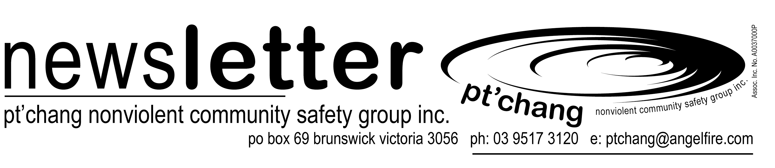

legal observer team at M1
Pt’chang has decided to organise a second large-scale Legal Observer Team, this time for the multitude of protests that will take place on Tuesday 1 May this year. Like S11, the protests on May Day will again be a creative range of actions against the impacts of corporate globalisation mainly centred in Melbourne’s CBD and involved a range of political, community and union organisations.
Pt’chang’s experience from the Legal Observer Team we organised at the World Economic Forum protests in September last year will put as in good stead to have an even more effective presence at the May Day protests coming up.
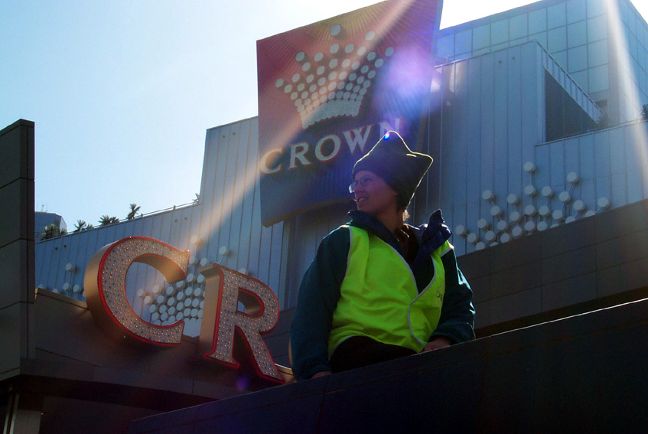

Liz Scarfe being a Legal Observer at S11
Pt’chang will be holding planning meetings each Wednesday night leading up to May 1st and will hold a Legal Observers Training/Briefing Day on Sunday 29 April at the Yarra Youth Centre at 156 Napier St Fitzroy. Starting at 11am to 4pm the day will involved a legal briefing, workshoping our protocols and running through our procedures as a team.

to get involved…
It would be great if many people who acted as Legal Observers at S11 were also available for May Day in order to use and build upon our combined experience. People interested in becoming involved for the first time will need to attend the training and briefing day.
There is a lot to organise but the results from our efforts at S11 indicate that our role as impartial observers had a definite effect in reducing some violence and creating some safety for activists.
We are also currently seeking $6,000 from law firms, individual barristers and unions in order to properly fund this project, equip ourselves with digital photographic gear and radios. If you can assist in anyway with our fundraising efforts this would be much appreciated. Please ring the office on 9415 6642 if you would like to get involved or come along to a Wednesday Pt’chang meeting.

welcome to pt’chang
If this is your first pt’chang newsletter then welcome! This newsletter goes out about five or six times a year and is the main way of staying in contact with the 200 or so people who are interested in Pt’chang’s work and projects.  Please make sure that you let us know if your contact details change so that we aren’t sending | this to empty houses. If you have items to contribute then send them to us at the email or post address above. This issue was put together and sent out by Elvira, Anthony, David and Melissa.  Enjoy the read!  Pt’chang

pt’chang has an office!
Pt’chang has recently moved into an office space at 124 Napier Street in Fitzroy. The office, which we are sharing with Peace Brigades International (Victoria), is upstairs in social change resource space behind the Uniting Church. The space is provided at a highly subsidised rate by the Uniting Church.

To find the office, go around the Church at 124 Napier Street to the left. The office is up the stairs on the first floor to the right.
Finally we have an accessible resource space, a place to store much of Pt’chang’s equipment and training materials and a workspace to run the many administration tasks it takes to maintain Pt’chang these days.

office needs:
Whilst we do have some office equipment already in place, Pt’chang is seeking donations of the following items:

- A IBM compatible desktop computer (with 32 to 64meg RAM, Pentium 200 or faster processor, CD ROM drive, good working condition);
- A compatable printer in good working order;
- A two, three or four drawer filing cabinet;

If you have any of the above items to donate to Pt’chang please contact the new office phone/fax number on 03 9415 6642 and let us know. Any material support is greatly appreciated. We currently plan to staff the office one or two days per week most likely on each Tuesday and Wednesday. Please ring first if you like to visit the office or help out in the setting up stage or in staffing the office from time to time.

psycoroborree report
On Sunday 11th and Monday 12th of March, Pt’chang fielded a peacekeeping and community safety team at Psychorobborree’s Gain Thump, an outdoor dance festival. After a site change, and a reduction of the event’s duration from three days to overnight, Pt’chang sent eight peacekeepers to the new venue at Cobbledick’s Ford, a small valley forty minutes west of the city. The event attracted around 300 punters and quite a few locals who’d come to check out what the noise was, or who’d been camping at the reserve for the weekend.
Pt’chang was on patrol from 8pm on the Sunday till 10am on the Monday. It was a very relaxed event, with only a few minor incidences, including the mis-identification of a lost dog, who was happily returned to his owner after a short stay in the Pt’chang chill out space.
Thanks to everyone who volunteered to go, even those who didn’t need to when the event was shortened. Everyone’s enthusiasm was much appreciated, and those who went seemed positive about the outcome.

David Shields

positions within pt’chang

Pt’chang has launched into a new era of having designated volunteer ‘positions’ in order to carry out many of the basic organisational functions of the group. These positions, although voluntary, will have clear position descriptions, support and those filling them will have expenses paid and be provided with a ‘honorarium’ of $100 per month in order to recognise the commitment and effort that they involve.

The positions available are listed below. Each position would only involve a few hours per week (averaged out) but would require at least six to twelve months commitment. All positions would be supported by and accountable to Pt’chang’s general meetings. All will make a huge difference to Pt’chang’s effectiveness and overall strength as an organisation.

People interested are to contact Pt’chang by Friday May 18 for a detailed position description and more information.

administration co-ordinator
Pt’chang Nonviolent Community Safety Group Inc. is seeking a competent Administrative Co-ordinator. The position involves responsibility for day to day office administration, as well as correspondence, liaison, networking and outreach tasks. Sound knowledge and skills in basic (Office 97) programs, as well as general office administration skills, are required. The position is voluntary but a honorarium is provided. For a Position Description phone 03 9415 6642. Applications close Friday 18 May.

finance co-ordinator
Pt’chang Nonviolent Community Safety Group Inc. is seeking a competent Financial Co-ordinator. The position involves responsibility for day to day accounting and bookkeeping, as well as assisting with budgeting and overall financial management of the organisation. Sound knowledge and skills in accounting programs (currently Quickbooks), as well as general bookkeeping skills, are required. The position is voluntary but an honorarium is provided. For a Position Description phone 03 9415 6642. Applications close Friday 18 May.

equipment co-ordinator
Pt’chang Nonviolent Community Safety Group Inc. is seeking a competent Equipment Co-ordinator. The position involves responsibility for the storage, maintenance, upkeep and replacement of Pt’chang’s community safety project equipment , as well as assisting with new acquisitions and forward planning. Own transport vehicle is preferred but not essential. The position is voluntary but an honorarium is provided. For a Position Description phone 03 9415 6642. Applications close Friday 18 May.

training co-ordinator
Pt’chang Nonviolent Community Safety Group Inc. is seeking a competent Training Co-ordinator. The position involves responsibility for the development and co-ordination of Pt’chang’s annual training program and workshops offered to other groups, as well as supporting and assisting the Training team within Pt’chang. Some experience in community based training is preferred. The position is voluntary but an honorarium is provided. For a Position Description phone 03 9415 6642. Applications close Friday 18 May.

pt’chang volunteer training calender

Pt’chang is yet again organising an extensive training callender that covers skills useful to the sort of community safety and nonviolent peacekeeping work that pt’chang does. The Training Working Group has been working hard to put together a program that provides comprehensive, high quality skills development and is accessable and affordable to all volunteers.
A one day Train-the-Trainer workshop was held for those interested in facilitating Pt’chang training sessions at the time this newsletter was going out in order to meet the increasing demand for Pt’chang Trainers to conduct sessions for other community groups and organisations. If anyone else is interested in the training side of pt’chang then please let us know. Speak to Melissa, Anthony or Carolyn.

mini-skills course 2001
Acredited First Aid Training is first off this year. (see below). Folowed in July and August with a ‘mini-skills course’ which will include: Drug and alcohol training, responding to sexual assault, people with mental illness, critical incident debriefing skills, legl rights and police powers and suicide awareness and response.
The Mini-skills course will be held on each Thursday evening for six weeks and participants can either book in for the whole course at a discounted rate or attend individual evening sessions.
Responding to Family Violence, Group Faciliatation and Mediation skills training are all planned for later in the year.

first aid training for pt’chang volunteers

Saturday 5 – Sunday 6 May, 2001

First Aid and life-saving CPR skills are important for all Pt’chang volunteers and an incredibly useful asset for everyday life. Pt’chang has arranged another opportunity for volunteers to do their Level 2 First Aid Certificate with St John’s Ambulance for half price! Costing only $75,this two-day training will take place on Saturday 5 and Sunday 6 of May at the St John’s training venue in Melbourne. Participants do not have to have completed level 1 first aid to do this training.

People interested must book in as soon as possible and pay in full by Friday April 27. Bookings can be made by calling the Pt’chang office on 03 9415 6642. or directly to Simon Berryman on 0408 561 753. The venue will be at the St John’s Ambulance training centre in Melbourne. Apparently the workshop is filling up fast so please be quick.

Participants will receive a first aid manual and an accredited Level 2 First Aid Certificate from St John’s Ambulance.

peace brigades international (pbi) update
PBI Australia recently hosted a nine-day Indonesia – East Timor Project training at Commonground in Victoria. The intensive training was for volunteers intending to spend 12 months in Indonesia or East Timor involved in the peace-building conflict resolution and protective accompaniment work of PBI. Trainees came from as far away as Sweden and Uraguay to attend the training and joined others from New Zealand and from Queensland and Victoria.

The Training intensively covered PBI’s role and mandate working in conflict zones, cultural awareness, political analysis and included lots of roleplays and intensive exercises. It was conducted by Micheal Beer from the US and Angela Morgan from Adelaide who had recently returned from working with PBI in West Timor. Those Australians soon to go over to Indonesia include Paul Zeccola from Melbourne who has worked with Pt’chang on a number of projects will join two other Australians, Kim vanden Nouwelant and Shane Guthrie, who are currently on the team. Kim will soon be joining the small PBI team in Aceh, the highly troubled western province of Indonesia, to continue protective accompaniment work with several Acehnese human rights organisations who have been recently threatened.

Paul Zeccola is planning to head to Indonesia in mid-May this year to join the project. Pt’chang would like to take this opportunity to wish Paul all the best with Peace Brigades and offer our support and help in any way.

anti-violence project- victoria
Pt’chang has recently become a member of the Anti-Violence Project (AVP) Victoria. AVP is a Melbourne based group whose mission is the prevention and elimination of violence and hate speech against lesbians, gay men, bisexuals and transgender people and their communities. AVP hopes to bring about change in the community by conducting education campaigns directed at the general community as well as within the GLBT communities.
Pt’chang held an information stall and five members attended a ‘Foum on Violence’ at the Brunswick Town Hall on the 18th January this year and is interested in working with and suppoting the AVP in the future. | orientation to the alcohol & other drugs sector
AVP- Vic can be contacted at:  C/- 6 Claremont St. Sth Yarra 3141  Email: vicavp@yahoo.com  Website: http://au.geocities.com/vicavp | The Youth Substance Abuse Service (YSAS) is offering free competency based alcohol,and drug training around Victoria over May and June. The training is a two-day accredited course which covers effects of drugs, risk and protection framework, treatment options, approaches and referral, harm minimisation, identification of substance use issues, communication with and supporting young people.  Contact Ysas for more information on 9415 8882 or via the website at www.ysas.org.au
Anyone interested in supporting Paul or the work of PBI financially can contact PBI at the office on 03 9415 6642.

new pt’chang meeting venue:
Pt’chang now meets fortnightly on Wednesday evenings at the new offce space at 124 Napier Street, Fitzroy. Please note: The current venue is not wheelchair accessable but an alternative acessable venue can be provided with a day or two notice. Please contact the office if you require accessability for a wheelchair. All meetings are facilitated, use consensus and are the main decision-making forum for Pt’chang. Arrive 6.30pm for a 7pm start. The next few meetings are: May 2, 16 and 30, June 13 and 27 and July 11. | Pt’chang involves a diverse range of people with skills and experience in a wide range of areas including community development, community health, social work, conflict resolution, counseling, psychology and social change movements. No experience is necessary to be involved in Pt’chang.  Pt’chang also has an email announce list and an email discussion group.

incoming : training, workshops & events

april 2001
Legal Observer Team Briefing :One day Training and briefing for Pt’chang Legal Observer Team volunteers.
where : Yarra Community Youth Centre- 156 Napier Sreet, Fitzroy.
when : Sunday April 29. 11am to 4pm

may 2001
First Aid Level 11 Training :Must for Pt’chang volunteers Half the regular price at $75 through St John’s Ambulance. Contactv Simon on 0408 560 753 to book in. Payment must be received by April 27!!!
where : Melbourne, Inner City
when : Saturday May 5 and Sunday May 6, all day.

may-june 2001
Orientation to the Alcohol and Other Drugs Sector: Free two day, competency based training provided by Youth Substance Abuse Service. Various venues and dates around Victoria. Excellent accredited training opportunity! Contact: YSAS at www.ysas.org.au for details.
where : Melbourne CBD
when : 22-23 May or 5-6 June or 26-27 June

if undeliverable please return to:
pt’chang – po box 69 brunswick
victoria australia 3056

